
Year 10
REVISION

End of Term 1 Test

2018

Name: ______________________

Show working and answers on this sheet. Show working in sufficient detail to support your answers. Incorrect answers without supporting reasoning will be allocated zero marks.

Resources: 1 A4 page of notes (1 side), Calculator allowed.

Algebra

Question 1

Simplify the following.

- 5a +2b – 4a + 7b b) 5g – 4( 3 - f)

Question 2

If d = -3, e = 4 and f = 2 calculate the following.

a) d + e + f = b) 2e – 4f =

- (f – e)² = d) 5d– 8f =

Question 3

Simplify the following indices. Give your answers as positive indices.

Simplify the following indices.
- 2b⁵. 4b²c³ b) $\frac{f^{4 }s^{5}}{f^{2}s^{5}}$ c) $g^{3}$. $h^{4}$.$h^{3}$.$g$ d) $\frac{{15a}^{2 }b^{3}}{{5a}^{}b^{5}}$ e) $d^{-5}$

Question 4

Expand and simplify the following:

- 8(4$s$ + 2) c) $(2b+2)(b-3)$

- (5d + 3)(d – 4) d) -4$t$(𝑡 - 5)

Question 5

Simplify the following algebraic fractions:

a) $\frac{9h}{3}$ b) $\frac{d}{3}+\frac{4d}{3}$ c) $\frac{5d}{4}-\frac{3d}{2}$ =

d)$\frac{t}{2}×\frac{3s}{4}$= e) $\frac{2a}{4} ÷\frac{3a}{3}$ =

Factorising

Question 6

Factorise the following:

a) 16h – 4 b) $5d+25d^{2}$ c) 7de + 28ab

Question 7

Fully factorise each of the following.

(a) 3(d – 2) + f(d – 2) (b) 3b(4h + 3) – 4(4h + 3)

Surface Area

Question 9

Determine the surface area of the following 3D Shapes:

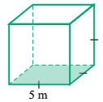

b)
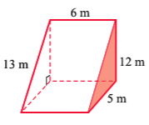
Question 10

Calculate the surface area of the following composite solids

a)

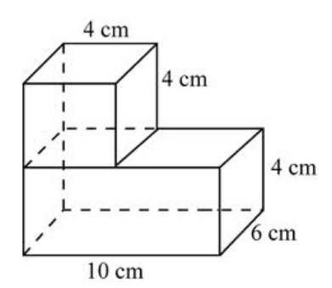

Question 11

Calculate the surface area of a cylinder with base radius of 12 cm and a height of 18 cm.
(HINT: Draw a diagram and use the formula if needed)

Volume

Question 12

Count the cubes and calculate the volume of each prism. (Each cube is 1cm³.)

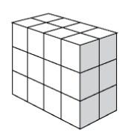

Volume =_______________

Question 13

Work out the area of the triangle and use your answer to
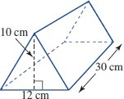
find the Volume of the shape.

Question 14

Calculate the Volume of the following 3D Shapes.

a)

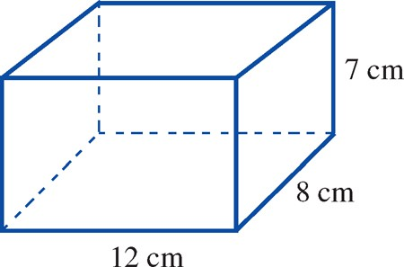

b)
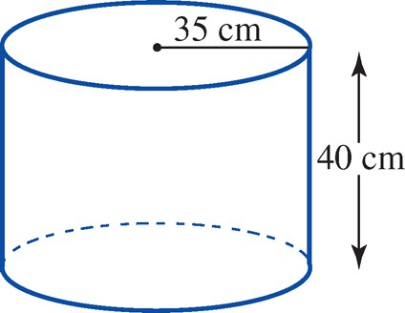

Question 15

Calculate the volume of the following solid

